**Project#01**

# **Project Overview:**

**Project Title:**

*“Scanning & Formatting a PDF Document”*

**Objective:**

The PDF document in this project is: ***“Bruce Barton Fundraising Letter; 100% Response Rate”*** The primary objective of this project is to accurately replicate the layout, text alignment, and spacing of a scanned document within a Microsoft Word document. This includes ensuring that the headings, paragraphs, bullet points, and overall formatting are consistent with the scanned original.

# **Before & After**

## **Before:**

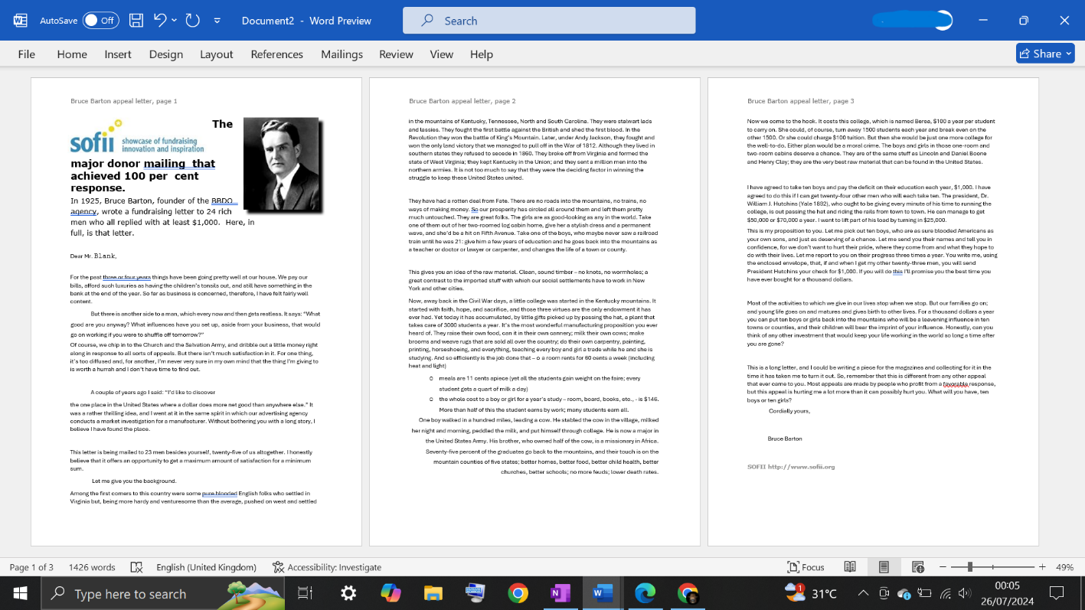

## **After:**

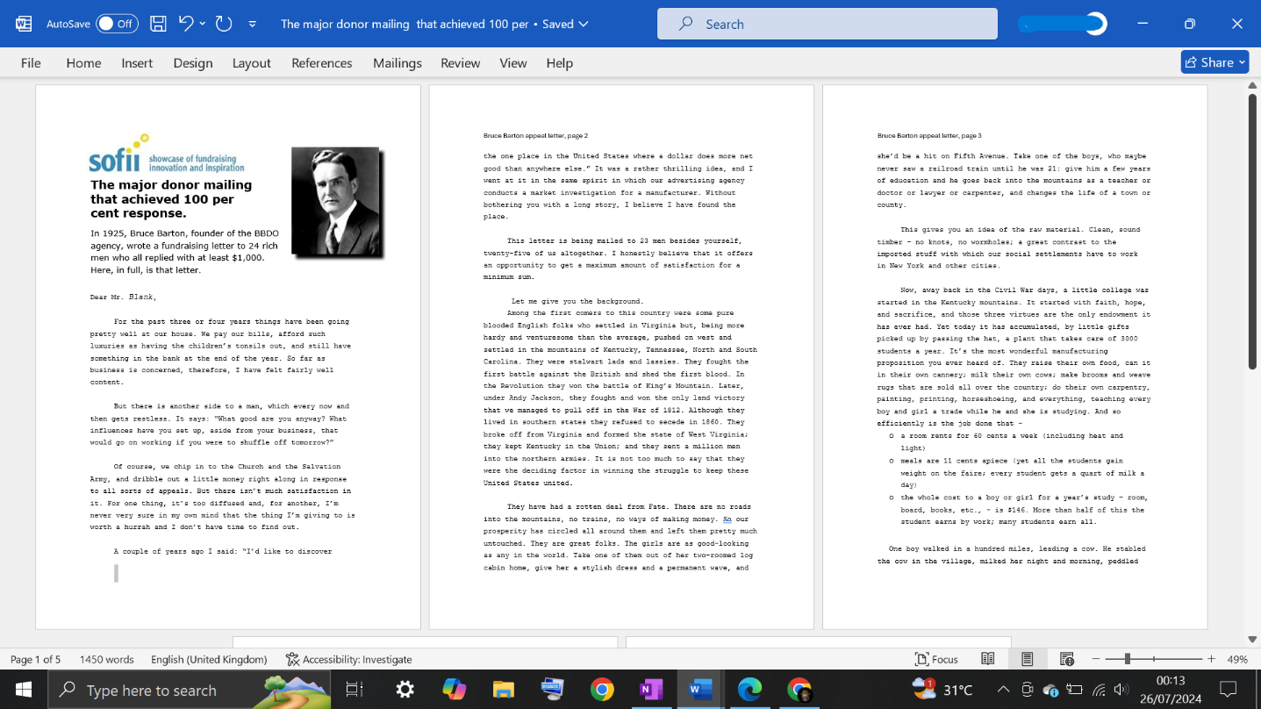

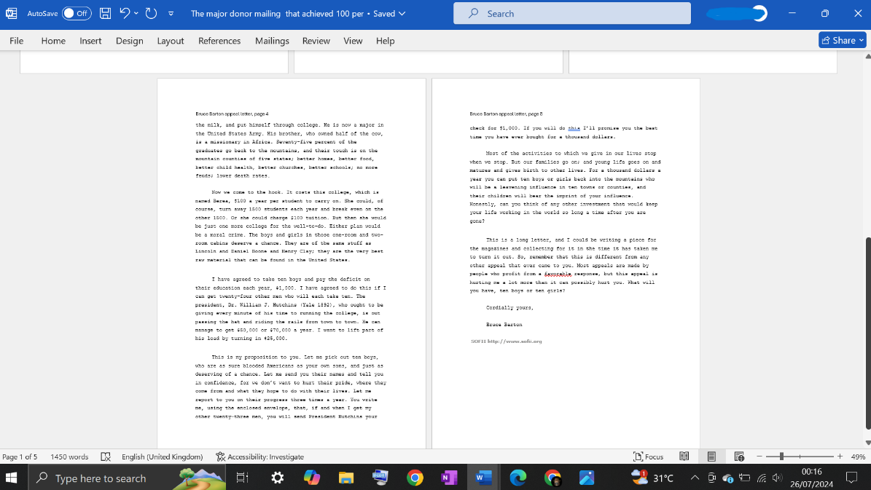

# **Process:**

* **Document Layout:**

-Set the page margins and orientation to match the scanned document.

-Defined and applied appropriate styles for headings and body text.

* **Text Alignment:**

-Aligned the text to match the original document’s format (left aligned).

-Ensured that special text elements, such as bullet points are correctly aligned.

* **Spacing:**

-Matched the line spacing and paragraph spacing with the scanned document.

-Adjusted the indentation for paragraphs, bullet points, to mirror the original layout.

* **Fonts and Formatting:**

-Identified and applied the correct fonts and sizes used in the scanned document.

-Ensured the consistent use of bold, italic, and other text styles where applicable.

# **Document LINK:**

Visit the following link to see the project:

https://drive.google.com/drive/u/0/folders/1_VwLl7wXaqU-WA4hHg3ZwTdCb6iu9iX8